

UNIVERSITI TEKNIKAL MALAYSIA MELAKA
FAKULTI TEKNOLOGI DAN KEJURUTERAAN ELEKTRONIK DAN KOMPUTER

BERR 2243
DATABASE & CLOUD SYSTEM

SEM 2 2024/2025

EXERCISE : WEEK 1

No | Name | Matrix No | Photo
1 | NURUL ANIS HAFIFZA BINTI AMRAN | B122410321 | 
2 | NUR AIN HIDAYAH BINTI ABDUL RAHIM | B122410323 | 

NURUL ANIS HAFIFZA BINTI AMRAN (B122410321)

- GitHub Repository : https://github.com/anishafifza

- Screenshots of :

- MongoDB connection with NodeJS
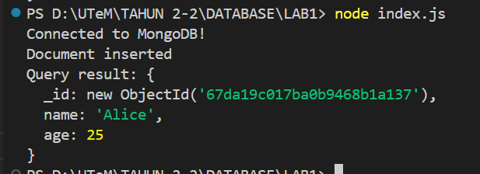

- Document in MongoDB Compass
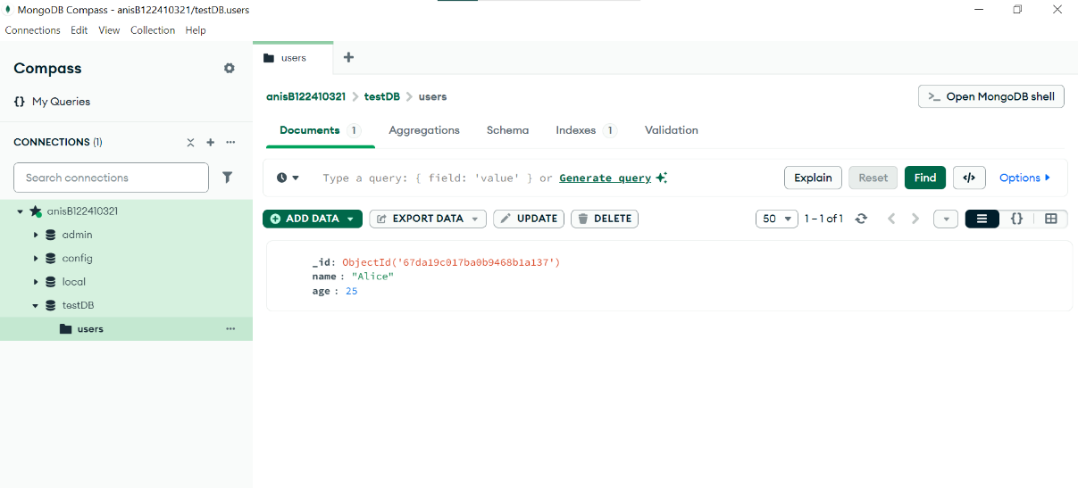

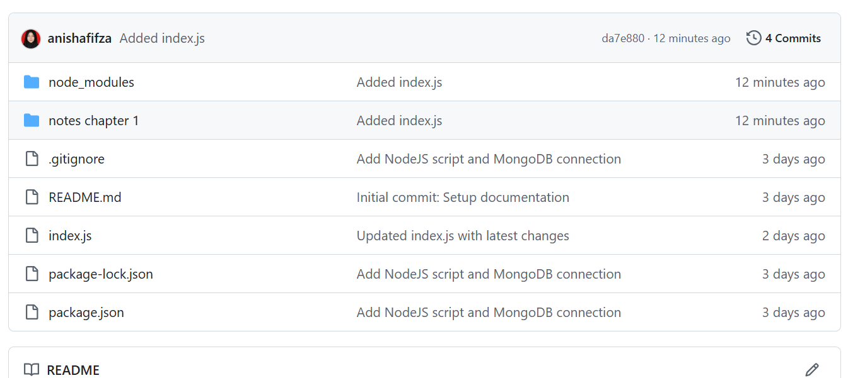

Exercise Questions

Answer :

- Code Execution & Output

After running your index.js script:

- What exact text does the console display when the document is inserted?
- What _id value is automatically assigned to the document?

- Modify and Observe

Change the name field in index.js to your own name and the age to your birth year. Run the script again.

- What new _id is generated for this document?

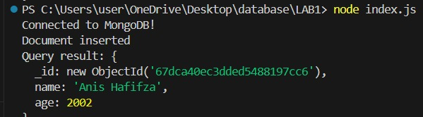

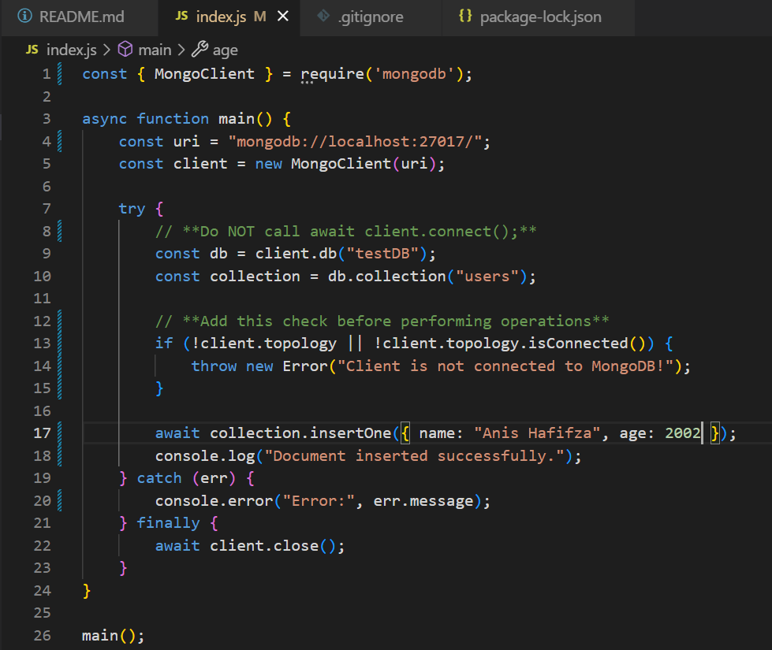
- What error occurs if you forget to call await client.connect()?

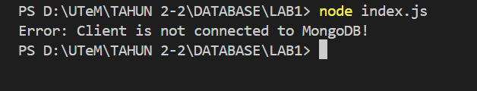
- MongoDB Connection Failure

Intentionally break the MongoDB connection string (e.g., change the port to 27018)

- What error message does NodeJS throw?

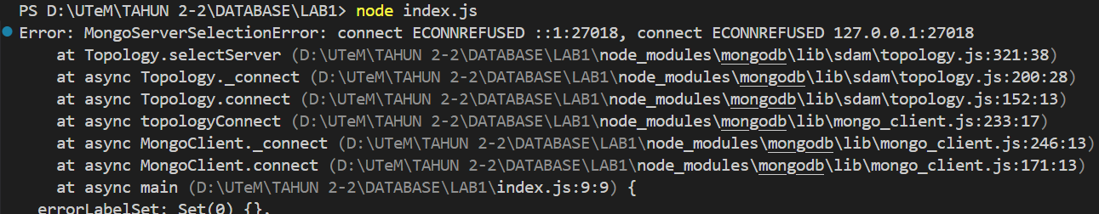

- What is the exact text of the error code (e.g., ECONNREFUSED)?

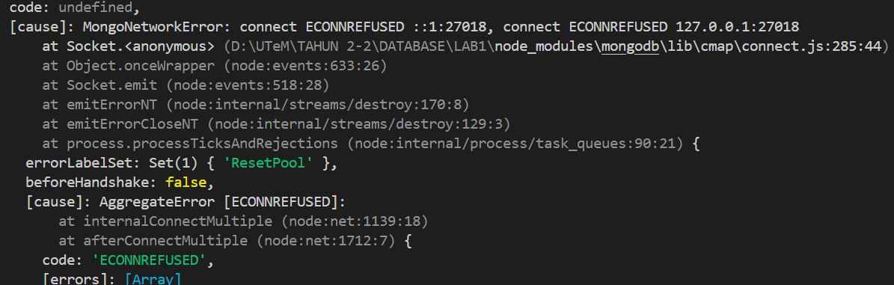

- MongoDB Shell Query

Use the MongoDB shell (not Compass) to:

- List all documents in the testDB.users collection.
- What command did you use? Paste the full output.

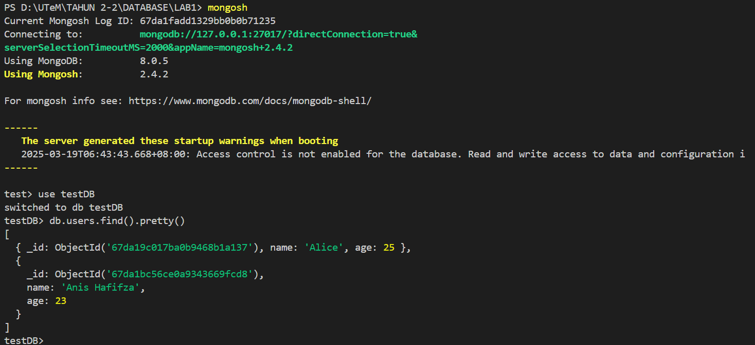

- File System & Dependencies

- What is the absolute path to your project’s package-lock.json file?
- What exact version of the mongodb driver is installed?

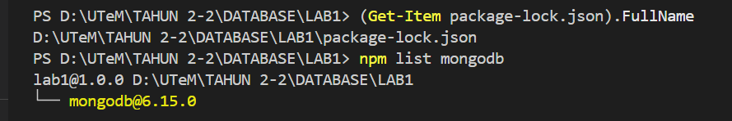

- Troubleshooting Practice

Stop the MongoDB service and run the script.

- What error occurs?

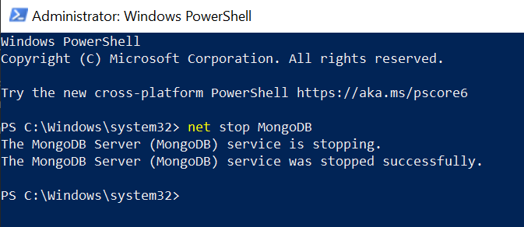
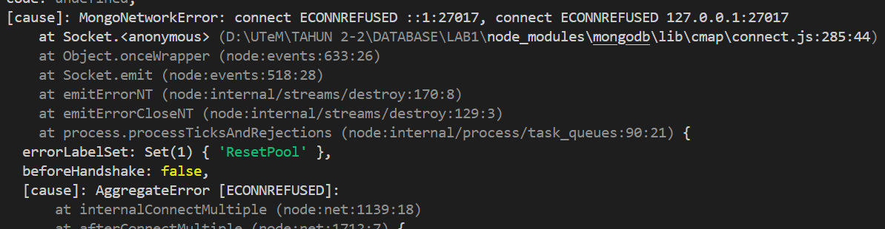

- What command restarts the service?

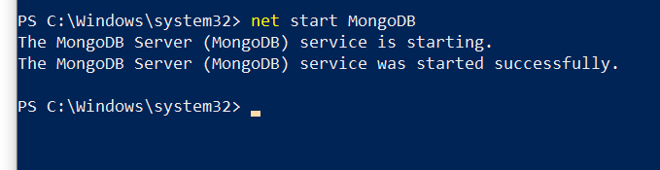

- GitHub Repository Structure

On GitHub, navigate to your repository’s.

- What timestamp is listed for your last commit?

Commits on Mar 22, 2025
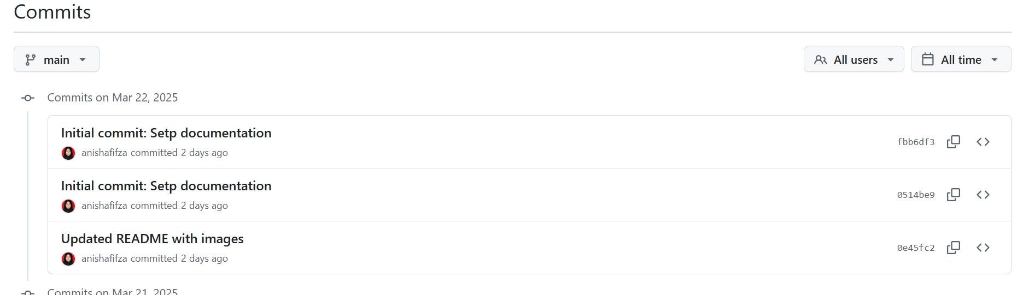

- How many files are present in this branch?

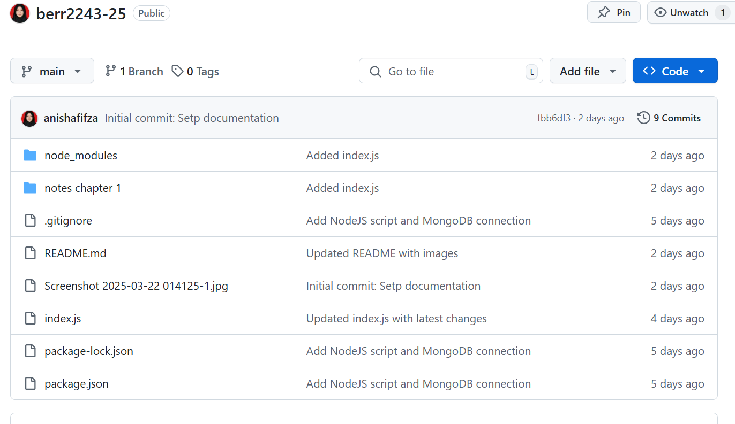

- Performance Observation

Time how long it takes for the script to print "Connected to MongoDB!".

- What is the duration (in milliseconds)?
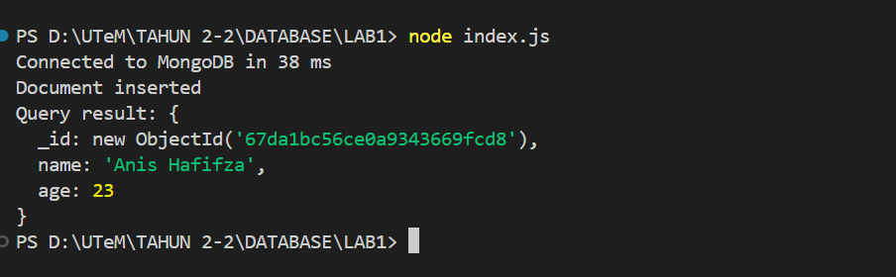

- Does this time change if you run the script again? Why?

Yes, when I run the script again the duration for print “Connected to MongoDB” was changed because MongoDB server load for handling other requests.

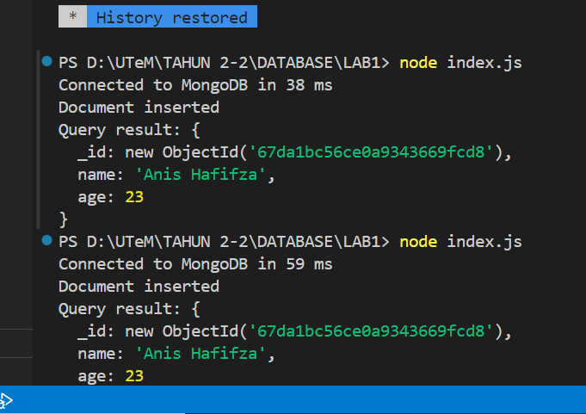

NUR AIN HIDAYAH BINTI ABDUL RAHIM (B122410323)

- GitHub Repository : https://github.com/b122410323/berr2243-25

- Screenshots of :

- MongoDB connection with NodeJS

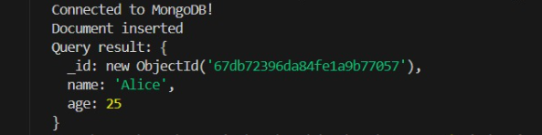

- Document in MongoDB Compass

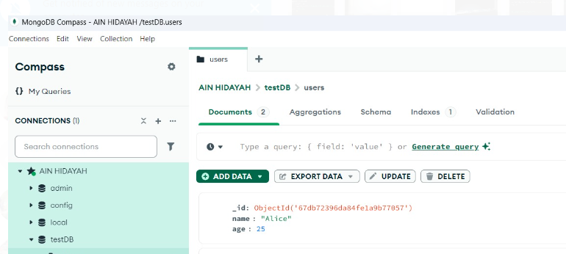

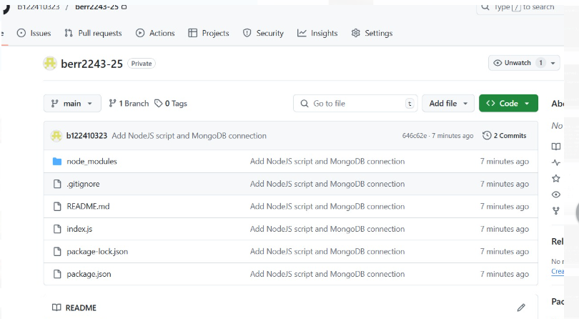

Exercise Questions

Answer :

- Code Execution & Output

After running your index.js script:

-What exact text does the console display when the document is inserted?

Connected to MongoDB

-What _id value is automatically assigned to the document?

67db72396da84fe1a9b77067

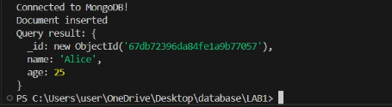

- Modify and Observe

Change the name field in index.js to your own name and the age to your birth year. Run the script again.

-What new _id is generated for this document?

67dca4640ad1279277dd7be3

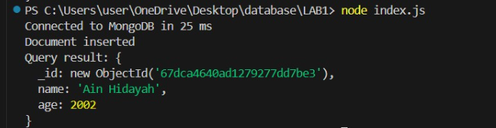

-What error occurs if you forget to call await client.connect()?

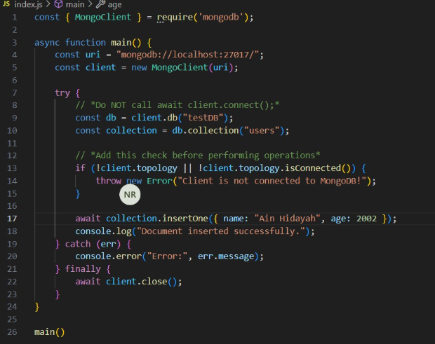

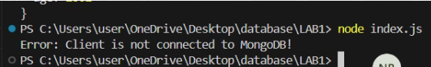

- MongoDB Connection Failure

Intentionally break the MongoDB connection string (e.g., change the port to 27018)

-What error message does NodeJS throw?

A connection failure “MongoServerSelectionError: connect ECONNREFUSED 127.0.0.1:27018”

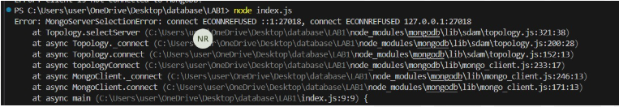

-What is the exact text of the error code (e.g., ECONNREFUSED)?

ECONNREFUSED
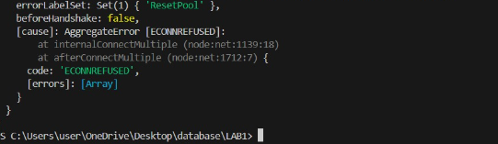
- MongoDB Shell Query

Use the MongoDB shell (not Compass) to:

-List all documents in the testDB.users collection.
-What command did you use? Paste the full output.

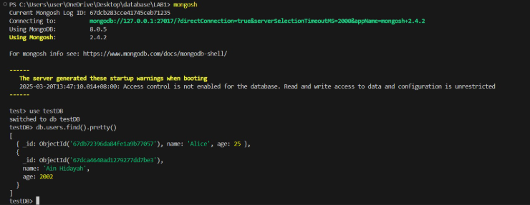
- File System & Dependencies

-What is the absolute path to your project’s package-lock.json file?
-What exact version of the mongodb driver is installed?

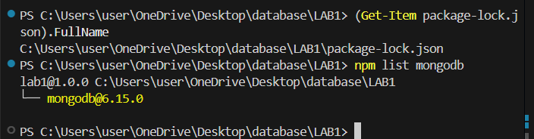

- Troubleshooting Practice

Stop the MongoDB service and run the script.

-What error occurs?

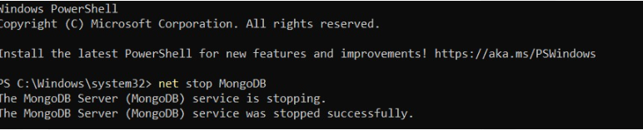
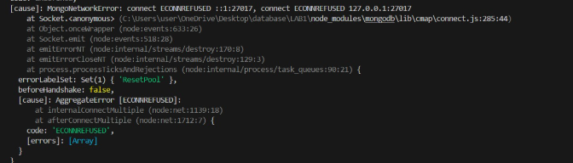

-What command restarts the service?
Net start MongoDB

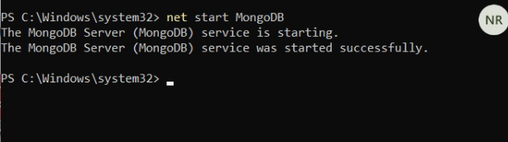

- GitHub Repository Structure

On GitHub, navigate to your repository’s.

-What timestamp is listed for your last commit?
Commits on Mar 20, 2025

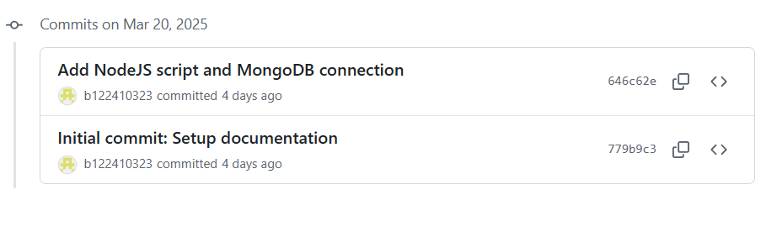
-How many files are present in this branch?
5 files

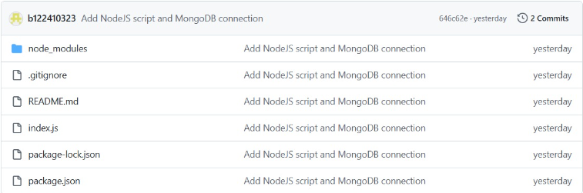

- Performance Observation

Time how long it takes for the script to print "Connected to MongoDB!".

-What is the duration (in milliseconds)?
22ms

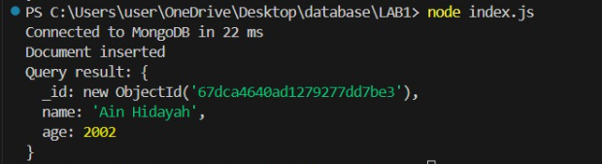

-Does this time change if you run the script again? Why?
Yes, it is can be faster or slower after the initial connnection because of the caching

